Tell your Turbos Ringette team all about YOU! Coach Heather will put everyone’s answers together in a document and you can learn all about your teammates and they can learn about you. You’ll be surprised how much you have in common!
Type | Question | Answer
About YOU | What’s your name? Let us know if you prefer your team to call you by a short form. For example, Liz instead of Elizabeth
 | What grade are you in?
 | When’s your birthday?
 | Add a picture of you from the summer and tell us about it | [paste photo here]
YOU and Ringette | How many years have you played ringette?
 | What’s your favourite thing about ringette?
 | What’s your favourite position? Centre, Forward, Defense, Goalie
 | How excited are you to play ringette this season? Pick a number from 1 -10, with 1 being “ugh, not ringette again” and 10 being “woo, I absolutely cannot wait, ringette is the best thing ever!!”
Cool things about YOU | Other than ringette, what other activities do you love to do? Examples: skiing, gymnastics, art, Llego, camping, girl guides and anything else!
 | Favourite TV show right now?
 | Do you have a favourite movie?
 | Favourite food?
 | Favourite subject at school? Examples: Math, science, English, French, Art, gym
 | Do you have a brother or sister? If yes, what’s their name and how old are they?
 | Do you have a pet? If yes, what are they and what’s their name?
 | Any other cool facts about you that you want your team to know about?

Type | Question | Answer
About You | What’s your name? Let us know if you prefer your team to call you by a short form. for example, Liz instead of Elizabeth | Evelyn
 | What grade are you in? | Grade 2
 | When’s your birthday? | August 1st, 2016
 | Add a picture of you from the summer and tell us about it | 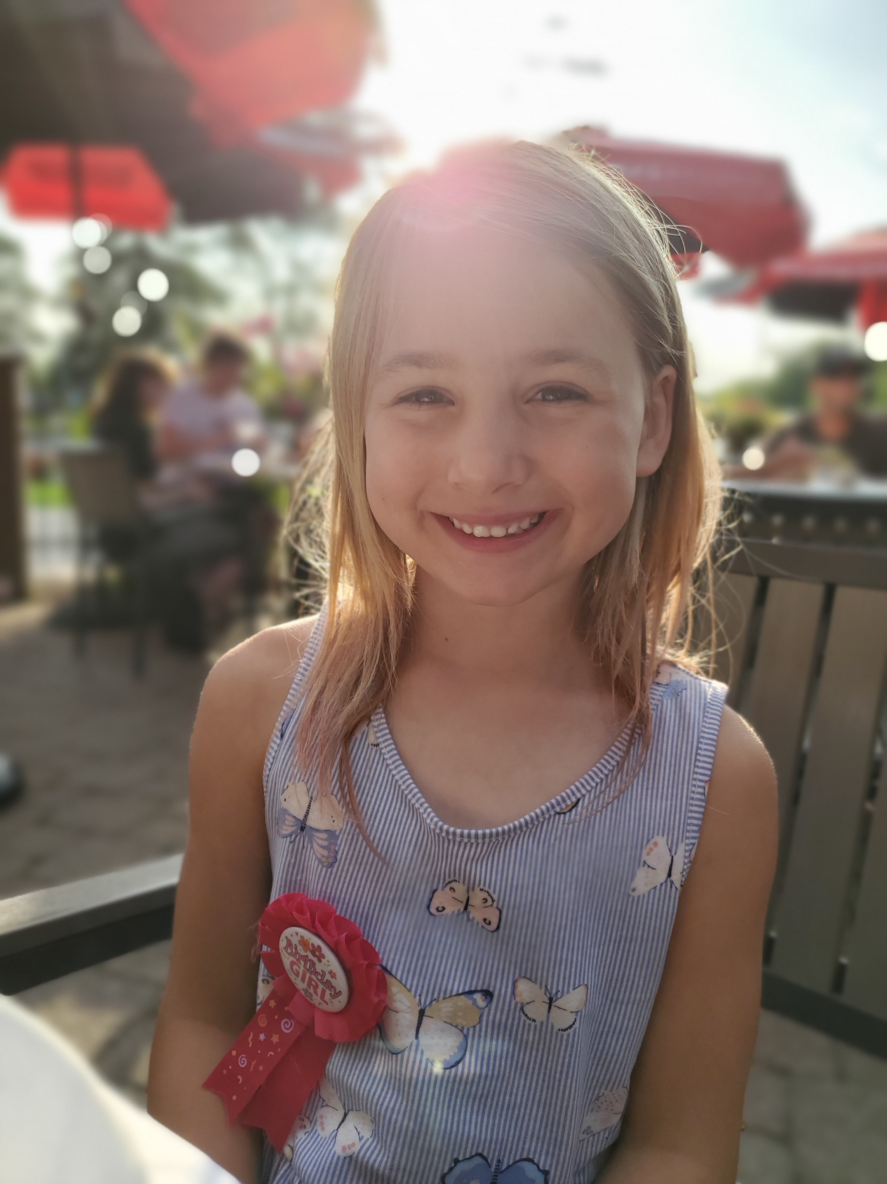  My 7th birthday dinner at Moose Winooski’s.
You and Ringette | How many years have you played ringette? | 3
 | What’s your favourite thing about ringette? | Playing ringette games with my team
 | What’s your favourite position? Centre, Forward, Defense, Goalie | Centre – I love all the skating
 | How excited are you to play ringette this season? Pick a number from 1 -10, with 1 being “ugh, not ringette again” and 10 being “woo, I absolutely cannot wait, ringette is the best thing ever!!” | 9
Cool things about YOU | Other than ringette, what other activities do you love to do? Examples: skiing, gymnastics, art, lego, camping, girl guides and anything else! | Swimming
 | Favourite TV show right now? | Jurassic World
 | Do you have a favourite movie? | Frozen
 | Favourite food? | Hamburgers
 | Favourite subject at school? Examples: Math, science, English, French, Art, gym | Art
 | Do you have a brother or sister? If yes, what’s their name and how old are they? | Alex and he is 5 years old
 | Do you have a pet? If yes, what are they and what’s their name? | A fish named Chase
 | Any other cool facts about you that you want your team to know about? | I was born in Australia.  My first two years of ringette were in Edmonton.  I speak English and French.

Parent Volunteer Example
Type | Question | Answer
About You | What’s your name? Let us know if you prefer your team to call you by a short form. for example, Liz instead of Elizabeth | Coach Heather
 | What do you do for work? | Scientist
 | When’s your birthday? | September 17
 | Add a picture of you from the summer and tell us about it | 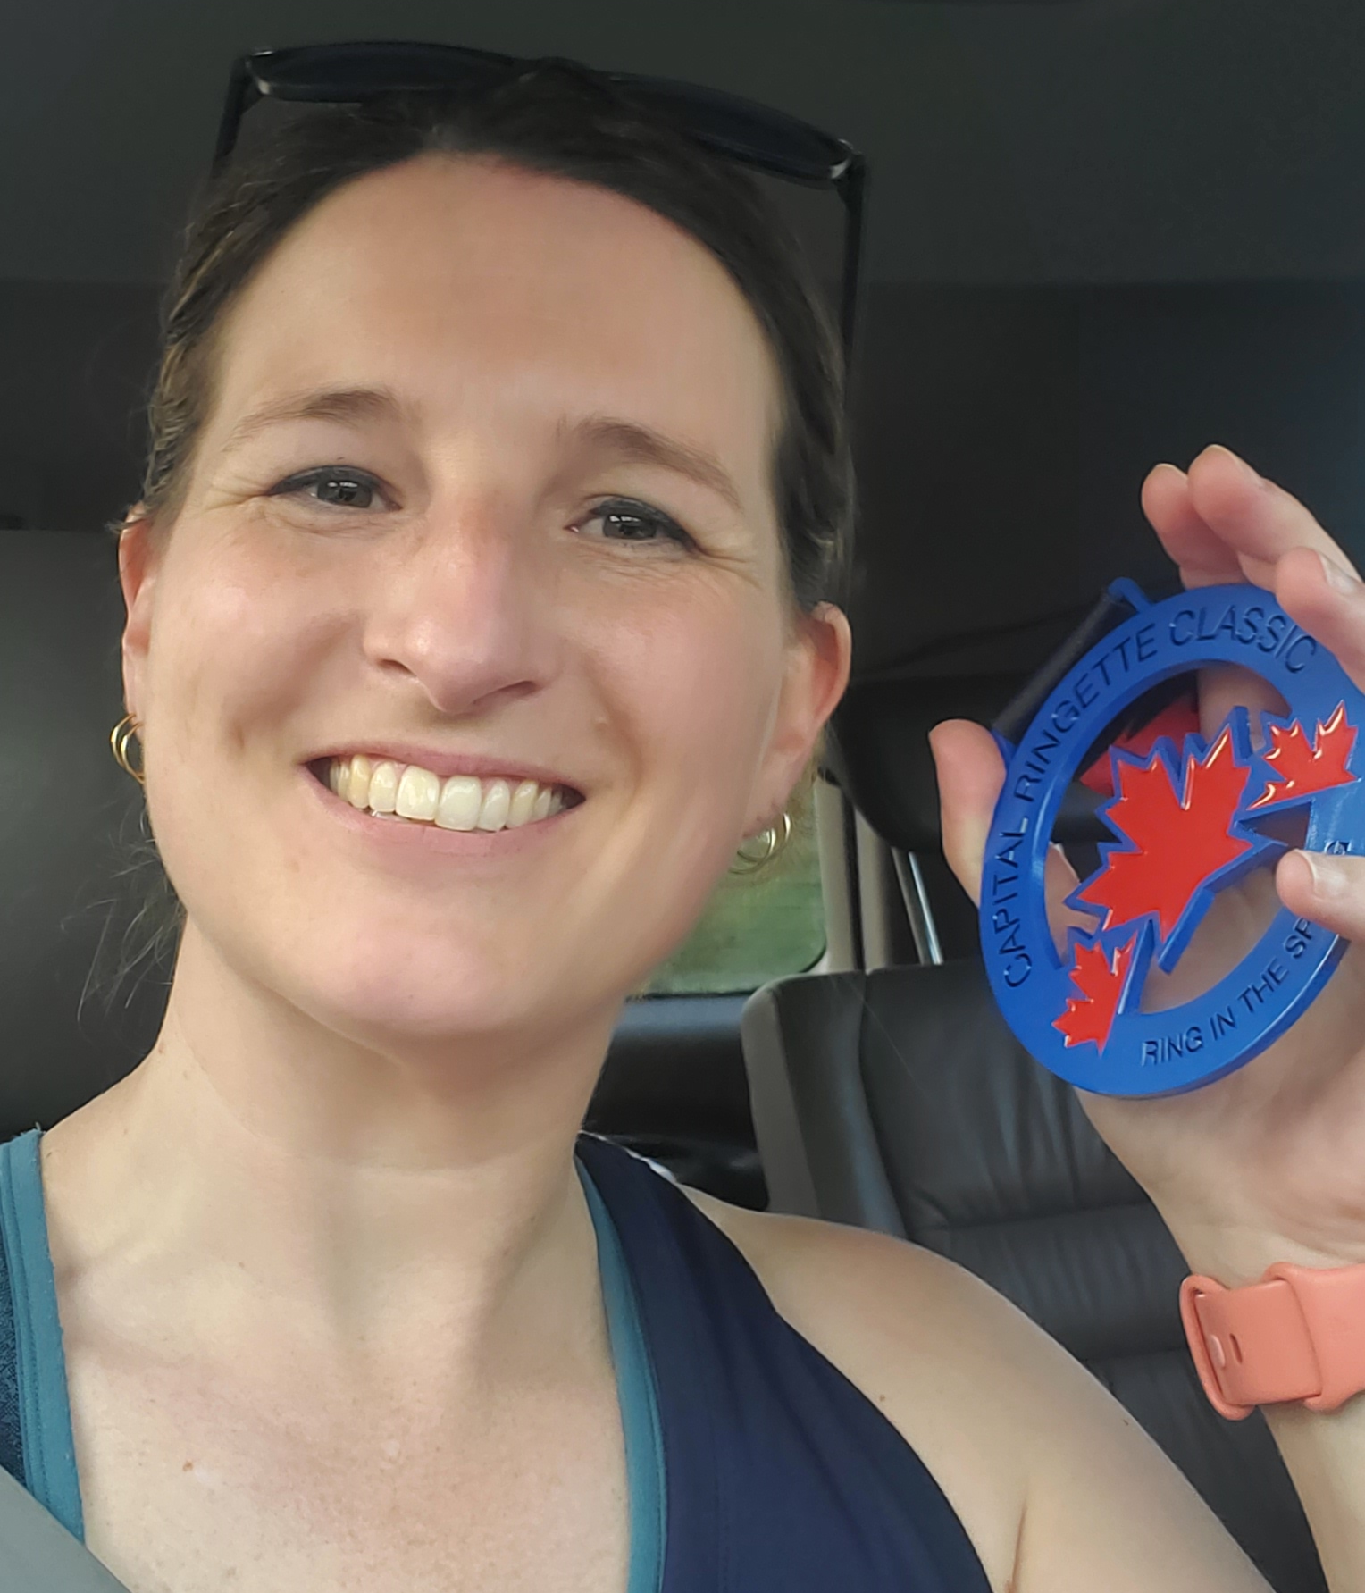  I played in a ringette tournament in June with my sister in Ottawa. I got an MVP medal and came in third for the tournament in points.
You and Ringette | How many years have you been involved in ringette? | This year marks 30 years since I started ringette.
 | What’s your favourite thing about ringette? | I’ve played many sports, and nothing compares to ringette. From the speed, agility, and game play to the life-long connections.
 | What’s your favourite position? Centre, Forward, Defense, Goalie | Forward – I love setting up my teammates for goals.
 | How excited are you to play ringette this season? Pick a number from 1 -10, with 1 being “ugh, not ringette again” and 10 being “woo, I absolutely cannot wait, ringette is the best thing ever!!” | 20
Cool things about YOU | Other than ringette, what other activities do you love to do? Examples: skiing, gymnastics, art, lego, camping, girl guides and anything else! | Camping, gardening, puzzles
 | Favourite TV show right now? | I love sci-fi and fantasy shows (e.g. Wheel of Time, Star Trek)
 | Do you have a favourite movie? | Same as above (e.g. Lord of the Rings, Star Wars)
 | Favourite food? | Deep dish pizza
 | Favourite subject at school? Examples: Math, science, English, French, Art, gym | Science!
 | Do you have a brother or sister? If yes, what’s their names? | Two sisters: Sarah and Laura. They both play ringette and Sarah coaches my niece at Fun 2 in Nepean.
 | Do you have a pet? If yes, what are they and what’s their name? | Just my children ;)
 | Any other cool facts about you that you want your team to know about? | A year after we got married, my husband Remi and I moved to Australia so I could get a Master’s degree. This was supposed to be a 1.5 year adventure, but we ended up staying for a decade so I could get my PhD in molecular biology. While I was there, I tried to start ringette but got a tad busy with school. I did play hockey on a tiny rink with my husband (check out our Anything for Hockey entry: https://www.youtube.com/watch?v=aaPB4BpTQpo) and I played and coached Broomball. The men’s team I coached won Nationals and I got recruited to play for Team Australia.  Our family moved back to Canada and landed first in Edmonton, where we lived for four years. We moved to Cambridge last year and are thrilled to be back in Ontario (I’m from Ottawa).

